**Cost savings related to energy use of an hybrid system (Heat pump + Gas Boiler) compared to a Gas Boiler system**

I have made a simple modification of our row house model. I have added the possibility to add some information to the output block and compare the costs of an hybrid system with the cost of a boiler system.

These are the results for a heat pump with a thermal capacity of 3000W with a seasonal COP of 3. I do not know what is the seasonal COP we can achieve with our heat pump but I took this value based on the information of the REHVA journal of 2014 about Efficiency of Heat Pumps in Real Operating Conditions from a monitoring campaign in Germany. [link](https://www.rehva.eu/fileadmin/REHVA_Journal/REHVA_Journal_2014/RJ_issue_5/P.07/07-12_RJ1405_WEB.pdf)

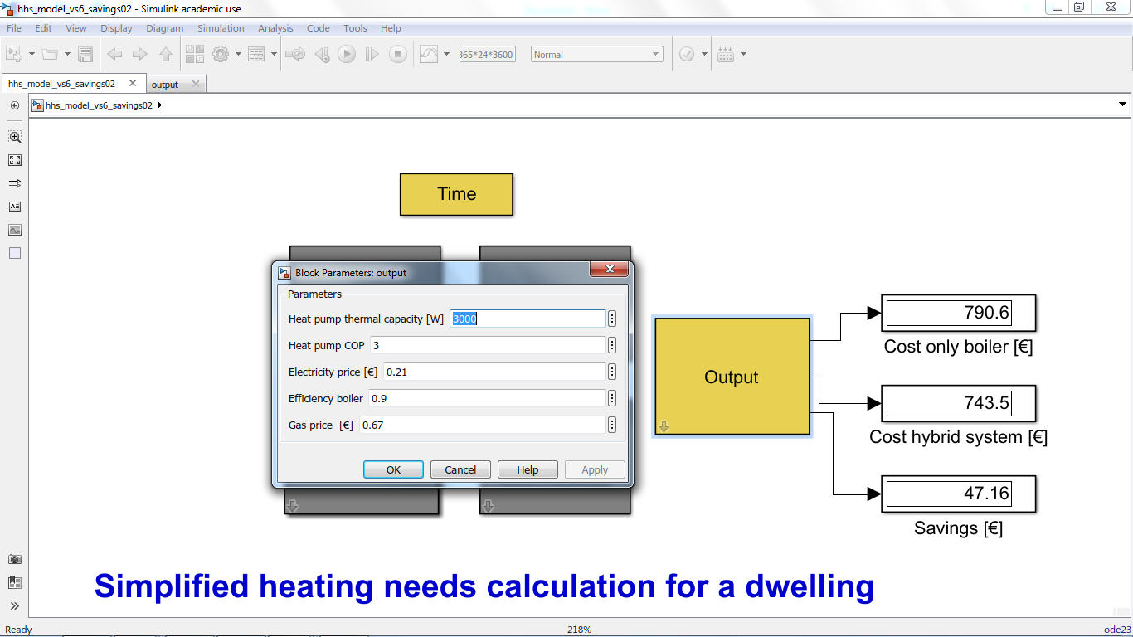

I have placed the model on our shared space is the file called hhs_model_vs6_savings02 that is placed in the folder House Model HHS > Model Arie BS07 – Row House.

If you run the model you can change the values of the variables and see what happens for a higher COP or a higher thermal capacity.

Take into consideration that this model is really simple, we are using a single seasonal COP in place of a COP that is depending on the difference of temperature between source and sink.

As you will see there are really small savings, but I think this is not a surprise. The price of gas are pretty low compared to the electricity prices. If you would like to discuss about these results we can agree on our next meeting time.

Best Regards,

Baldiri Salcedo and Arie Taal